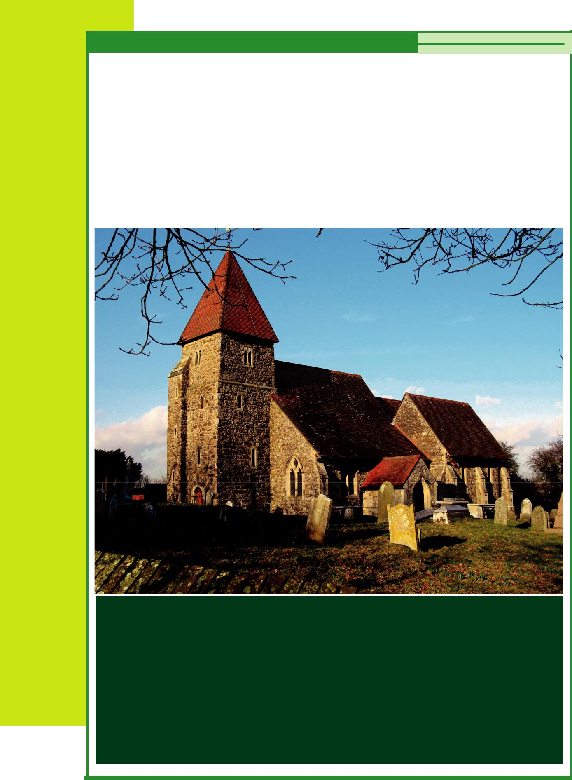

GUESTLING AND

THREE OAKS

ACTION PLAN 2015-2020

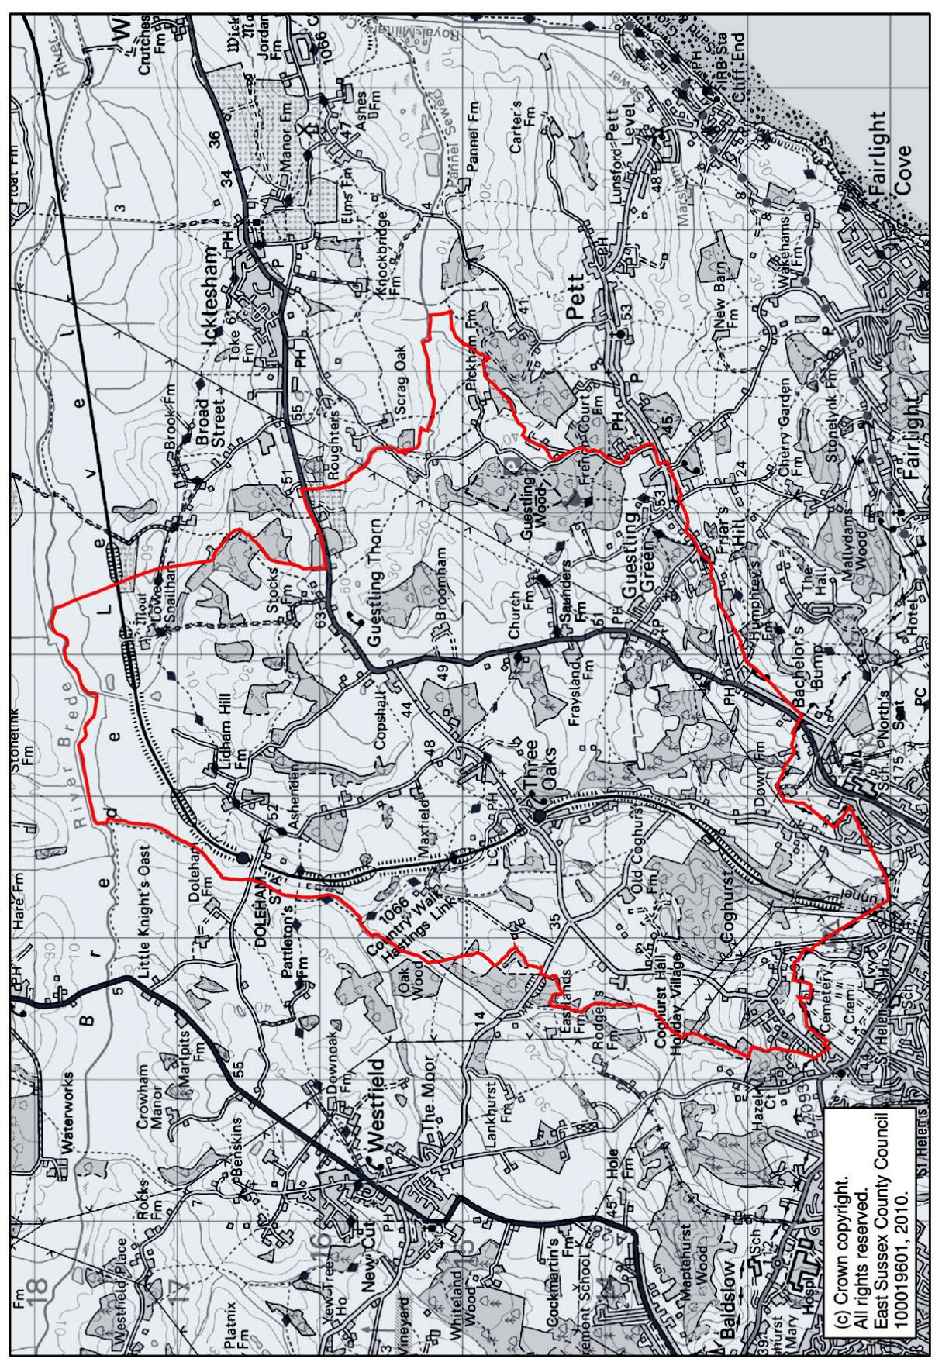

Ordnance Survey map of Guestling and Three Oaks provided by ESIF www.eastsussexinfigures.org.uk parish boundary outlined in red

THE PARISH OF GUESTLING AND THREE OAKS

The parish of Guestling and Three Oaks lies about 4 miles north-east of Hastings on and around the A259 in the High Weald AONB (Area of Outstanding Natural Beauty).
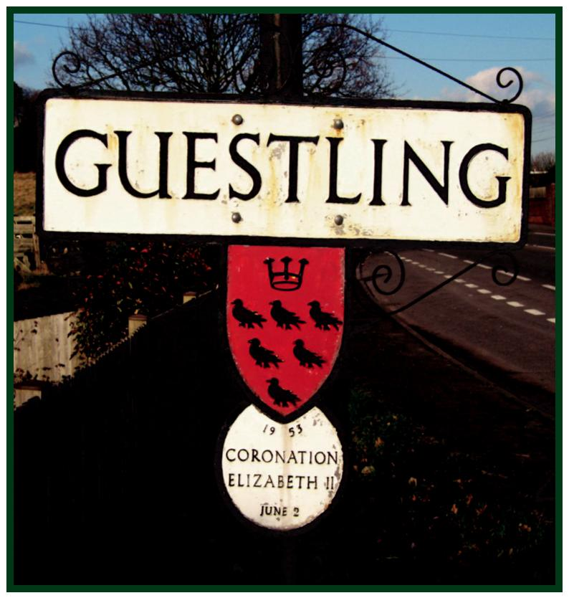

Guestling is derived from the Anglo Saxon Gestling (Gesta's family). Gestlinges is one of the three villages mentioned in the Domesday book as being part of the rape of Gestlinges also including Luet (Modern Pett) and Ramslie (a large manor including Fairlight). The Main Court for the Western towns in the Cinque Ports was held at Guestling.
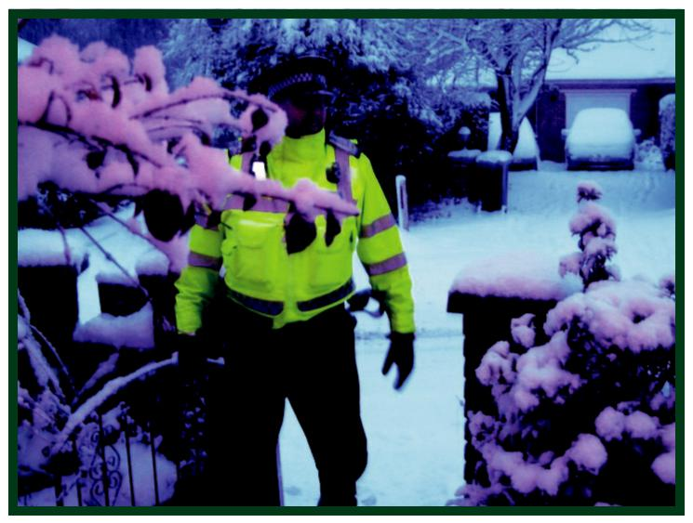

Three Oaks has its own village hall and Guestling village hall is beside the junction with the A259 and Church Lane which leads to the Church of St. Laurence

Hand made bricks are made in Fourteen Acre Lane, Three Oaks. The Guestling bricks are in great demand for

restoring Churches and other old buildings. Customers have included Camber Castle, Hampton Court and Buckingham Palace.
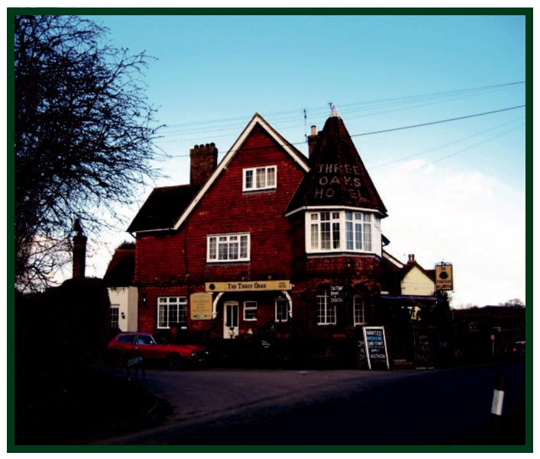

Guestling and Three Oaks are served by two public houses. The

Three Oaks in Butchers Lane and the White Hart on the A259.

One of England's great scholars at the time of Shakespeare’s birth was Gregory Martin. He was born in Maxfield, an old timbered house in Three Oaks. He became the tutor in the house of the Duke of Norfolk and spent the last years of his life

at Rheims. Here he translated the Latin Bible into English. He died in 1582 and is buried in Rheims.

The parish is crossed by a network of public footpaths and bridleways, providing great walking and panoramic views of the Sussex countryside.

What is an Action Plan and why is it important?

The Action Plan offers the opportunity for the wider community to be involved in shaping a vision for the future of their parish

It covers the issues that affect daily life

It helps to identify community priorities through consultation (all those who completed and returned the Guestling and Three Oaks

‘Have Your Say’ questionnaires were involved in this part of the process)

The actions within the plan detail what is required to address community needs

Implementation of the actions will mean improvements in the quality of life of local people

Having an Action Plan can result in an increased number of people becoming involved in getting projects completed

Copies of this Action Plan will be presented to Guestling and Three

Oaks Parish Council, Rother District Council, East Sussex County Council, other agencies and service providers to inform them of the aims and aspirations of the parish

The Guestling and Three Oaks Action Plan will be reviewed annually and updated every five years to ensure it continues to be relevant to the needs of local people

The Action Plan Steering Group will report at the Annual Assembly on the implementation of actions giving the community the opportunity to gauge the success of this Action Plan

ACTION PLAN FOR THE PARISH OF GUESTLING AND THREE OAKS

ACTION ONE

PRESERVE THE HISTORY AND RURAL NATURE OF THE PARISH

98% of residents responding to the questionnaire felt that living in an Area of Outstanding Natural Beauty was important to them and support preserving the history and rural nature of the parish. To ensure that the historic buildings such as St. Laurence Church are protected.

To seek assurances from the planning authorities that their policies will support the objectives of the High Weald AONB and also ensure that changes within the parish will reflect its essentially rural appearance.

To support the preservation and maintenance of St. Laurence Church.

Those involved: Guestling Parish Council, Rother District Council,

East Sussex County Council. St. Laurence Church PCC

Timescale: 1-5 years, subject to annual review

ACTION TWO

CONTINUE TO CAMPAIGN FOR A REDUCTION IN TRAFFIC SPEEDS
THROUGHOUT THE PARISH

90% of residents responding support a reduction to the current speed limit in the parish.

86% support the Speed Watch campaign to monitor traffic speeds through the village and passing data collected to Sussex Police for action against offenders to enforce current speed limits. Additional comments were made regarding speeding on Butchers Lane, Friars Hill, Pett Rd, Winchelsea Rd and the country lanes which are being used as ‘rat runs’. In particular the speed limit on Friars Hill should be reduced to 30mph.

34% of residents responding would be prepared to assit in the monitoring of curent and proposed traffic activity.

49% were of the opinion that the new Bexhill to Hastings link road would increase the number of vehicles passing through Three Oaks, with a detrimental affect on the village.

To monitor traffic speeds and campaign for a reduction in current speed limits in the parish.

Those involved: Guestling Parish Council, Sussex Police, East Sussex County Council, Highways Agency

Timescale: 1-5 years or until achieved

ACTION THREE

CONTINUE TO CAMPAIGN TO EXCLUDE COMMERICAL VEHICLES FROM
IVY HOUSE LANE

80% of residents responding to the questionnaire support the exclusion of commercial vehicles from Ivy House Lane. Whilst access should be maintained appropriate measures could be put in place to prevent larger vehicles using it as a cut through. The lane is felt to be unsuitable for wide and heavy vehicles, particularly when speeding, putting vulnerable road users at risk.

To seek support from all relevant authorities to exclude commercial vehicles from Ivyhouse Lane except for direct access to the Industrial Estate from The Ridge or for essential access to domestic properties.

Those involved: Sussex Police, East Sussex County Council, Guestling Parish Council, FTA, Road Haulage Association

Timeframe: 1-5 years

ACTION FOUR

CONTINUE TO SUPPORT THE NEED FOR IMPROVEMENTS TO PUBLIC
TRANSPORT SERVING THE PARISH

82% of residents responding to the questionnaire felt that there was a need for improvements to public transport.. Public transport enables better access to services, entertainment, employment and education.

To continue the campaign for regular train services on the Hastings to Ashford railway service and a reliable bus service between Hastings and Rye providing at least one method of public transport to either Guestling or Three Oaks.

Those involved: Guestling Parish Council, East Sussex County Council,

local bus operators, train operators, Marsh Link Action Group

Timeframe: 1 - 5 years

ACTION FIVE

IMPROVE AND PROMOTE LOCAL PATHWAYS

89% of residents responding to the questionnaire said that would like to see improvement and promotion of the local footpaths, improve access and the condition of footpaths, stiles and gates.

To Providing details of local pathways and continuing to ensure the improvement and maintenance of our pathways will help to encourage the health and well being of the community.

Those involved: East Sussex County Council, Guestling Parish Council, Doctor’s Surgery local rambling groups

Timescale: 1 - 5 years

ACTION SIX

UPGRADE AND IMPROVEMENT OF THE PLAYING FIELD AND PAVILION

80% of residents responding to the questionnaire would like to see an upgrade and improvement of the playing field and pavilion.

Those involved: Guestling Parish Council

Timescale: 1 - 5 years

ACTION SEVEN

IMPROVE THE CONDITION OF ROAD SURFACES

95% of residents responding to the questionnaire are unhappy with the condition of the road surfaces within the parish.

To report pot holes and poor road conditions to East Sussex County Council and the Highways Agency.

Those involved: East Sussex County Council, Highways Agency, Guestling Parish Council,

Timeframe: 1 - 5 years

ACTION EIGHT

ENSURE THAT THE PARISH CONTINUES TO BE A SAFE PLACE TO LIVE

The parish is a safe place to live in the opinion of 92% of residents responding to the questionnaire. To ensure that Guestling and Three Oaks continue to be perceived as safe and that the current situation is maintained and improved for the future the following steps will be taken:

Promote active Neighbourhood Watch schemes to improve prompt reporting and awareness of local crime and antisocial behaviour.

Ensure that the parish continues to have a designated PCSO. Encourage more Police and PCSO foot patrols.

Those involved: Guestling Parish Council, Sussex Police, Safer Rother Partnership

Timeframe: 1-5 years

ACTION NINE

CONTINUE TO SUPPORT, PROMOTE AND DEVELOP THE PARISH WEBSITE www.guestling.org.uk

92% of residents responding to the questionnaire felt that the website should be supported and promoted to include information on local services, clubs, organisations and societies. Provide access to opportunities for training, education and employment. Encourage social interaction by publishing an events diary

Those involved: Connie Evans, Guestling Parish Council, Village Hall Committees, Rother District Council, East Sussex County Council, local businesses.

Timeframe: 1 - 5 year
ACKNOWLEDGMENTS

Thank you to the following people who have helped with the Guestling and Three Oaks Action Plan

Steering Group Members

Graham Macpherson, Ken Bourne, Dave Perrett,
Lynne Perrett, Connie Evans, Marion Roberts, Martyn Brown,
Andrea Brown, Andrew Eldridge

Photographs provided by

Paul Brown and Graham Macpherson

This Action Plan was made possible by the residents of Guestling and
Three Oaks who completed the ‘Have Your Say’ questionnaire, the steering group and all the volunteers who distributed questionnaire, together with
the Guestling Bradshaw School, The Butchers Shop, Chapel Lane Surgery and the Three Oaks Inn who all made a place for collection boxes for the returnof questionnaires.

PUBLISHED BY THE GUESTLING AND THREE OAKS STEERING GROUP

The actions contained within this plan reflect the views of the majority of the people
who completed and returned the Guestling and Three Oaks ‘Have Your Say’ questionnaire.

The Action Plan is owned by the community and will be reviewed on a regular basis to reflect the changing needs of local people. Interested groups and organisations have been identified to help progress these ideas, however, it is important that the community continues to be involved in delivering their aspirations as set out in this Plan.

Some of you have already indicated that you would like to volunteer your services to
help and we very much appreciate your support. However to make this Action Plan
a success and to ensure the parish continues to be a great place to live we would like
any member of the community who has a particular interest, skill, knowledge or
expertise to offer to help us to take these actions forward.

Contact: volunteer@guestling.org.uk
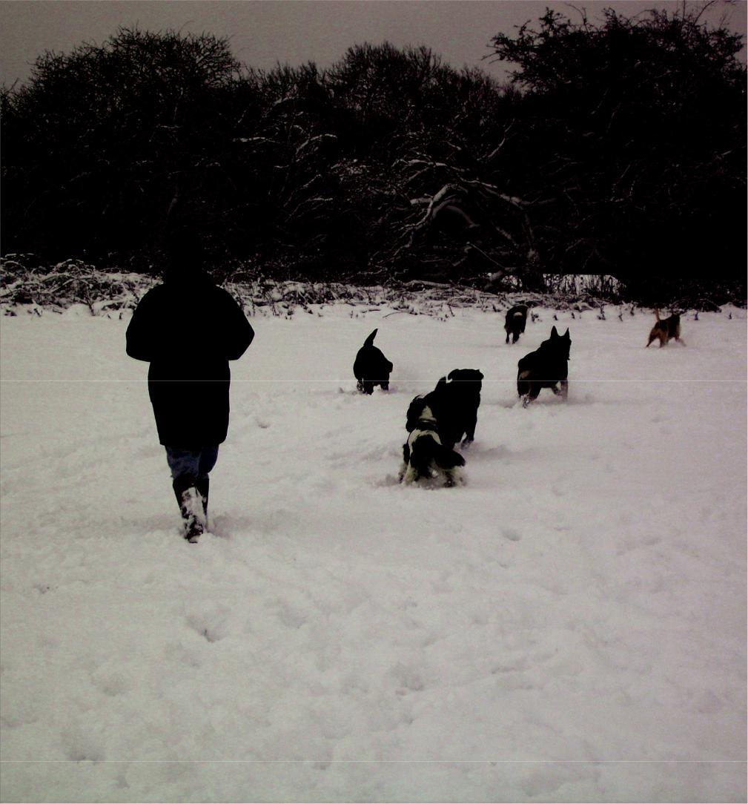

Please visit the website

www. guestling.org.uk

where you may view this Action Plan and read updates of progress and find more information concerning the parish of Guestling and Three Oaks

